INSURANCE FOR MISSION TRIPS

Whether you are traveling on an international trip or stateside
Gallagher Insurance is highly recommended

https://www.travelwithgallagher.com/

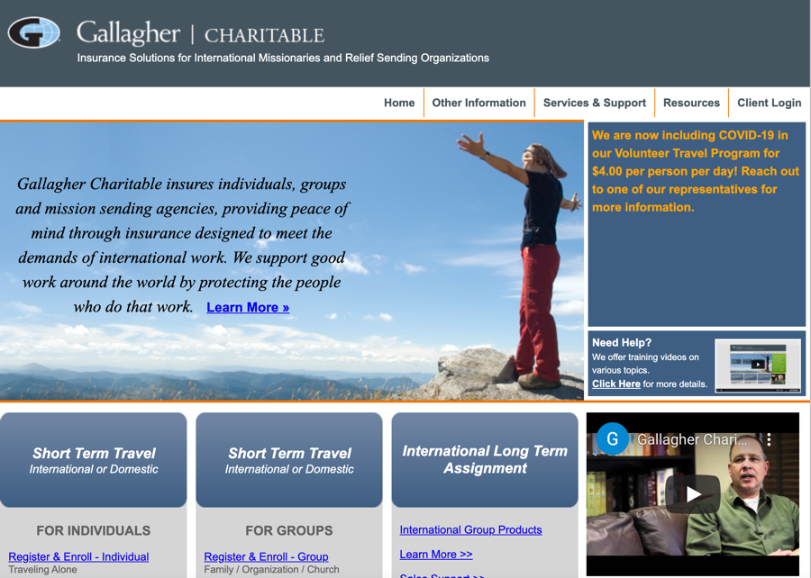

Your team leader will normally handle the logistics for your group when applying for insurance for travel.

The GBA office is more than happy to help with your application for insurance through Gallagher. GBA maintains an account with Gallagher Insurance.

Contact the GBA office for more information:
(731) 855-1202 or info@gbalife.org

www.gbalife.org

